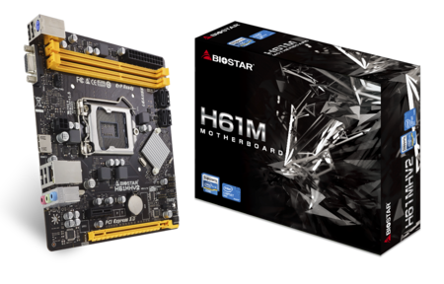 | H61MHV2 7.0  - Supports Intel 2nd and 3rd generation Core i7 / i5 / i3 / Pentium / Celeron processors in the 1155 package  - Supports 2 DIMM of DDR3 1600/1333/1066 MHz up to 16GB maximum capacity  - Supports USB 2.0  - Supports HDMI  - Supports GbE LAN

Chipset | - Intel H61
CPU SUPPORT | - Intel® Core™ i7 LGA 1155 Processor  - Intel® Core™ i5 LGA 1155 Processor  - Intel® Core™ i3 LGA 1155 Processor  - Intel® Pentium® LGA 1155 Processor  - Intel® Celeron® LGA 1155 Processor  - *Please refer to www.biostar.com.tw for CPU support list.
MEMORY | - Support Dual Channel DDR3 1600/ 1333 /1066 MHz  - 2 x DDR3 DIMM Memory Slots  - Max. Supports up to 16GB Memory
INTEGRATED VIDEO | - By CPU model
STORAGE | - 4 x SATA II Connectors (3Gb/s)
LAN | - Realtek RTL8111H - 10/100/1000Mb/s Controller
AUDIO CODEC | - Realtek ALC662 5.1-Channel HD Audio
USB | - 8 x USB 2.0 Ports (4 on rear I/Os and 4 via internal headers)
EXPANSION SLOT | - 1 x PCI-E 3.0 x16 Slot (supported by Core i5 -3xxx / Core i7 3xxx CPU)  - 1 x PCI-E 2.0 x1 Slot
REAR I/O | - 1 x PS/2 Keyboard Port  - 4 x USB 2.0 Ports  - 1 x HDMI Port  - 1 x VGA Port  - 1 x LAN Port  - 3 x Audio Jacks
INTERNAL I/O | - 1 x Chassis Speaker Connector  - 1 x Clear CMOS header  - 1 x Power Connector (24pin)  - 1 x Power Connector (4pin)  - 2 x USB 2.0 Headers (each header supports 2 USB 2.0 ports)  - 4 x SATA II 3Gb/s Connectors  - 1 x Front Audio Header  - 1 x Front Panel Header  - 1 x CPU Fan Connector  - 1 x System Fan Connector  - 1 x COM Port Header
H/W MONITORING | - CPU / System Temperature Monitoring  - CPU / System Fan Monitoring  - Smart / Manual CPU Fan Control  - System Voltage Monitoring
DIMENSION | - Micro ATX Form Factor Dimension: 17cm x 19.1cm ( W x L )
OS SUPPORT | - Supports Windows XP / Vista / 7/ 8/ 8.1/ 10  - ※Biostar reserves the right to add or remove support for any OS with or without notice.
BUNDLE SOFTWARE | - BIO-Remote2
ACCESSORIES | - 2 x SATA Cable  - 1 x I/O Shield  - 1 x DVD Driver  - 1 x Quick Guide
FEATURES | - Supports BIOS-Flasher  - Supports Charger Booster

CPU-Chipset Features

Intel H61 chipset  The Intel® H61 Express Chipset is a single-chipset design to support the new 1155 socket Intel® 3rd/2nd Generation Core™ i7 / Core™ i5 / Core™ i3 / Pentium® / Celeron® processors. It provides improved performance by utilizing serial point-to-point links, which allows increased bandwidth and stability. | 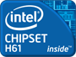
Intel LGA 1155 3rd Generation Intel Core™ Processor support  Intel 3rd generation processor "Ivy Bridge" is the codename for Intel's 22nm of the Sandy Bridge microarchitecture. The first to use tri-gate("3D") transistors, it is also backwards-compatible with the Sandy Bridge platform requiring a BIOS/firmware update. | 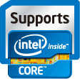

Audio+

HD Audio

Provides high quality sound with minimal loss of audio fidelity.

Video+

HDMI 3D Visual

The HDMI 3D Visual provides a level of interoperability for devices designed to deliver 3D content over the HDMI connection. The latest HDMI Specification adds key enhancements to support the market requirements for bringing broadcast 3D content into the home featuring key enhancements for 3D applications including the addition of mandatory 3D formats for broadcast content.
DX11

Direct3D 11 enables Direct3D 10 APIs and Direct3D 11 APIs to use one underlying rendering device. And it allows developers to achieve a high speed, fully conformant software rasterizer.

Speed+

Charger Booster

Charger booster is the best and efficient charger solution for apple devices such as iPad, iPhone. Basically, Charger booster Technology is able to boost the charging time to be more efficiency and faster once any apple goods connecting to our Motherboard. With charger booster technology, you are able to charge your apple devices up to 42 % faster.
PCIe Gen 3.0  PCIe 3.0 is the next evolution of the ubiquitous and general-purpose PCI Express I/O standard. At 8GT/s bit rate, the interconnect performance bandwidth is doubled over PCIe 2.0, while preserving compatibility with software and mechanical interfaces. | 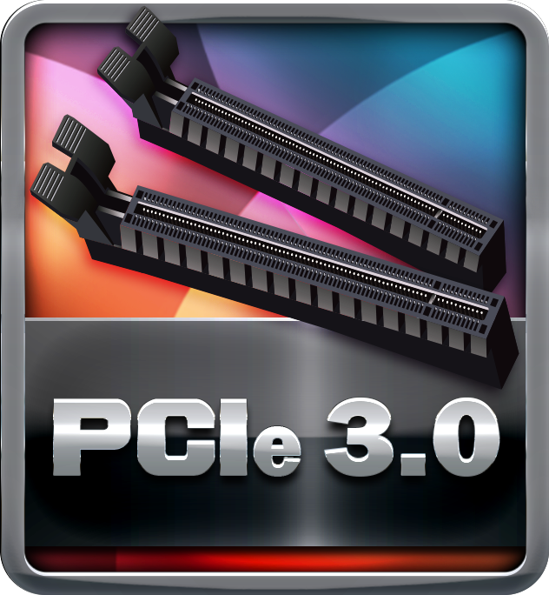
Dual DDR3-1600  It supports 2 or 4 DIMM Slots DDR3 memory that features data transfer rates of DDR3 1600/1333. The processor support 2 memory channels and setting the memory multiplier, allows selection of the channel speed. These clearly uplift the band width and boost the overall system performance. | 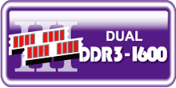

Durable+

X.D.C (eXtreme Durable Capacitors)

Biostar adopts low ESR and high ripple conductive solid state caps that provide sufficient, stable power supply to the CPU. The life span can also be more than 6.25 x of ordinary liquid caps.

Protection+

ESD Protection  ESD (Electrostatic Discharge) is the major factor to destroy the PC by electrical overstress (EOS) condition. ESD occurred by PC users when touch any devices connect to a PC, which may result in damage to the motherboard or parts. ESD protection is designed to protect the motherboard and equipment from damage by EOS. | 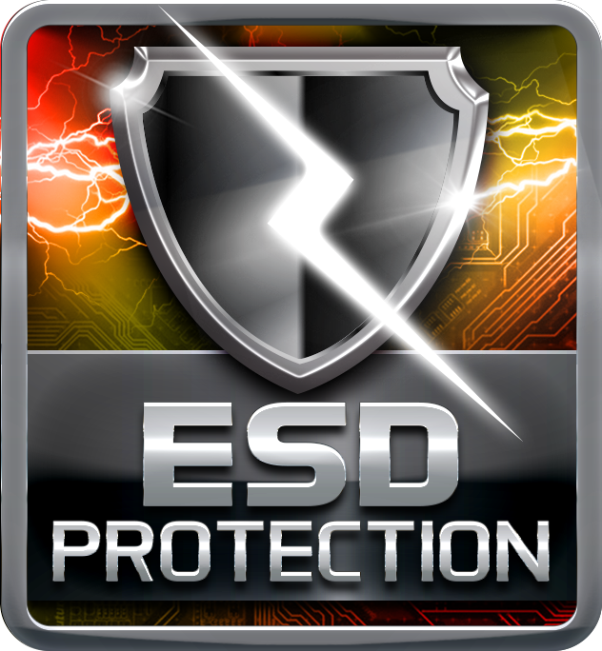
OC / OV / OH Protection

OC / OV / OH Protection design detects overvoltage conditions and prevents voltage surges from spreading in real time. It also actively cuts off the overvoltage supply to protect your system.
BullGuard Internet Security (90 days FREE trial)

BullGuard Internet Security comes with the broadest line-up of internet security features on the market, including: a cutting-edge dual Antivirus engine, Online Backup for your precious files, PC Tune Up to speed up your system, a Game Mode for a seamless gaming experience, Parental Control, Firewall, Safe Browsing and many more. Make the most of your digital life with Bullguard!

DIY+

Simplitec

"Simplitec" offers premium solutions to ensure your PC is faster, more reliable and free of security gaps - automatically or with customized setups. "Simplitec" is a free bundle software to scan your computer for problems and offers a professional solution for each problem to put your PC back in top form.
BIO-Flasher

BIO-Flasher is a convenient BIOS update tool. Just launch this tool and put the BIOS on USB pen driver before entering the OS. You can update your BIOS with only a few clicks without preparing an additional floppy disk or other complicated flash utility.
BIOScreen Utility

Personalize your desktop with customizable boot logo. BIOScreen is the new feature that lets you personalize and create your own style with unique, custom-made boot logo.

