SKMEI 1672 Operation Manual
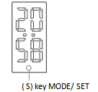

FEATURE
- 24H time display (LED display)
- body temperature measurement (LED display)
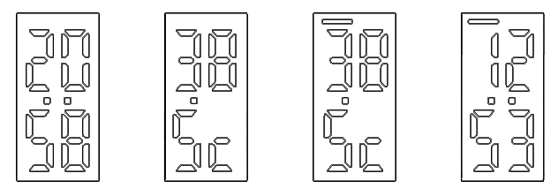
Charging (the left symbol flash)
Normal Temperature
Time Display
Abnormal Temperature (the left symbol flash quickly)

- Time display
- press S key to display the time, it automatically turns off to save electricity when there is no operation.
- Time setting
- Under the mode of time display , keep pressing S key for 5 seconds to enter the setting of “Hour” then press S key again to modify the number of “hour”. Press S key and hold it for 5 seconds again to enter the setting of “ minute” then press S key to modify the number of “minute”.

- Test the temperature
- Under the mode of time display, press S key to measure the temperature and the symbol ℃ flashes , symbol ℃ stop flashing after test finished.
- Attention: There are 2 abnormal results of measurements when the temperature is out of the range of 32℃~42.5℃: ①LO or HI means it too low temperature or too high temperature to be out of range of measurement.② Red light will flash when temperature exceeds 37.5℃。Within range of measurement.
- Measuring range is 34℃~42℃. Results of measurements will be affected individual difference, environment , clothing ,strenuous exercise and other factors . The result are for reference only and cannot be used as a basis for diagnosis .
Remarks: Wear your watch for ten minutes before detecting your body temperature;
- Charging
- Take off wrist band and connect it with USB charging cable
- Led screen display : On charging : The left symbol flash
Full charge : The left symbol stop flashing.

